A2P 10DLC CAMPAIGN FORM
Brand Information & Details
Legal Company Name: | Click to edit
DBA or Brand Name (if different from legal name): | Click to edit
Country of Registration: | Click to edit
What type of legal form is the organization? (Individual, publicly traded Company, Private Company, Charity/non-Profit Organization) | Click to edit
Tax Number/ID/EIN: | Click to edit
Address/Street: | Click to edit
City; State/Region;  Country;  Postal Code/Zip Code | Click to edit
Website: | Click to edit
Stock Symbol (if applicable): | Click to edit
Stock Exchange (if applicable): | Click to edit
Vertical Type: | Click to edit

Contact Details
Name: | Click to edit
Phone: | Click to edit
Email: | Click to edit
Address: | Click to edit

Campaign Information
Use Case (select one of the below)
Standard Types

2FA ☐
Account Notification ☐
Customer Care ☐
Delivery Notification ☐
Fraud Alert Messaging ☐
Higher Education ☐
Low Volume Mixed ☐
Marketing ☐
Mixed ☐
Polling and Voting ☐
Public Service Announcement ☐
Security Alert ☐

Special Types

Carrier Exemptions☐
Charity☐
Conversational Messaging☐
Emergency☐
Political☐
Social☐
Sweepstake☐

Campaign Content and Attributes

Subscriber Opt-in ☐
Subscriber Opt-Out ☐
Subscriber Help ☐
Number Pooling ☐
Direct Lending or Loan Arrangement ☐
Embedded Link ☐
Embedded Phone Number ☐
Affiliate Marketing ☐
Age-Gated Content ☐

Prerequisites:
Please do not submit the form without the prerequisites being completed
1) The company website submitted above must match the company name
Ex: ACME Corp and www.acme.com
2) The website must have HTTPS (SSL)
Site with no SSL will look like the below on your browser
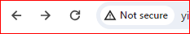 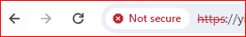

3) The website must have a disclaimer and the disclaimer must have wording like the following:
“Any personal information that we collect (as identified in the “Personal Data We Collect” section) will not be shared with third parties.”

4) If your website has a form (even if it’s not used for messaging) you must have a disclaimer beneath the form similar to the following:
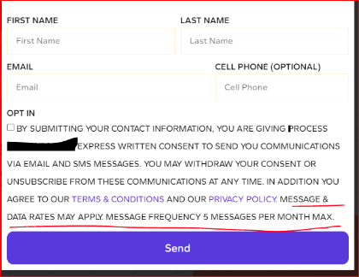

NOTE: The below fields are mandatory for any message campaign. The campaign will not receive approval with out them being filled out with as much detail as possible
Campaign Description:
Please be very specific and include as much detail as possible.
Example: This is a doctor’s office and patients receive appointment reminders and updates
Call-to-Action / Message Flow:
Provide a detailed description of how the customer’s opt-in and provide a screen shot from your website
Example: Customer’s sign up to receive messages via our website. Attached is a screen shot
Sample Messages
Sample message should include wording similar to, please respond with stop to stop receiving future messages
Example: This is [Company Name]. Your appointment is at 5pm EST. Please respond with stop to stop receiving future messages.

Opt-in message
Example: Welcome to [Company Name] thank you for signing up. We will receive messages from us for alerts, updates or appointments. Msg&data rates may apply. Reply STOP to cancel.
Opt-out message
Example: You've opted out of [Company Name]. updates. No more msgs will be sent. Reply HELP for assistance.) :Click to edit
help message
Example: For assistance with [Company Name]. updates, email [your email] or call [your number]. Reply STOP to cancel updates. : Click to edit

More Examples could be seen below:
